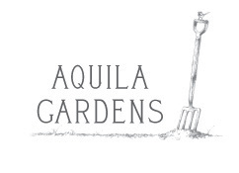
Lou Bull
mob: 0458 240 634
e-mail: loubull.aquila@gmail.com
ABN: 45038588092

ORDER & INVOICE:
“A Year in Aquila Garden”
Order For: |  | Any special messages or questions:
CUSTOMER NAME :
phone:
e-mail:
Delivery Address:

 | Description |  | Qty / Unit Type | Price per Unit | Gross
 | “A Year In Aquila Garden” Seasonal Guide to garden activities. |  |  | $25.00
 | For bulk orders of 20 - 50 plus please contact to arrange cost and delivery options. |  | 20-50 | $17.00
 | For design services please ring or e-mail
Postage
1 - $10
2 to 3 - $15
4 -12 - $20
Amount Due
Please note : no GST is being applied, this is not a tax invoice.
Preferred Payment Methods - direct deposit
Bank Name | Bendigo Bank | Account Name | DL Bull T/AS Aquila Gardens
BSB | 633 000 | Account Number | 154427546
Reference for payment | Your initial & last name eg:  T Smith | Cheque | cheques payable to DL Bull  “Aquila” Mitchell Rd Table Top NSW 2640
Receipt number |  | Receipt date

